Press Release: RPA Announces New Communications Director
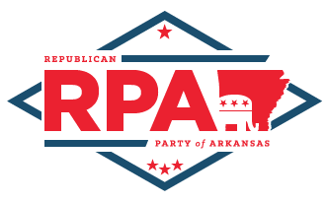

FOR IMMEDIATE RELEASE
Office of the Republican Party of Arkansas
501.372.7301
1201 W 6th St, Little Rock, AR 72201
Communications@arkansasgop.org

RNC Chairwoman Names Arkansas GOP Chairman as General Counsel to RNC

Little Rock, Ark. – On Feb. 21st, 2017, Republican National Committee Chairwoman Ronna McDaniel announced Republican Party of Arkansas Chairman Doyle Webb as the General Counsel to the RNC. Throughout his 9-year tenure as Chairman of the RPA, Webb has had the honor of serving on the budget and executive committees representing the southern region. Most recently, Webb served as Chairman of the RNC Committee on Contests and the Co-chair of the Convention Committee on Credentials for National Convention.

“I want to thank Chairwoman McDaniel for the confidence she has placed in me and for giving me this opportunity to expand my services to the members of the RNC and the Republican Party while continuing my service as Chairman of the Republican Party of Arkansas,” said RPA Chairman Doyle Webb.

Chairman Webb’s new national responsibility includes the administration and oversight of the Judicial Committee to the RNC. His work as an Arkansas attorney and his seniority as an executive official for the Republican Party are experiences that will serve him well on his new endeavor.

